**Department of (Computer Science)**

**Pak-Austria Fachhochschule: Institute of Applied Sciences and Technology, Haripur, Pakistan**

**COMP-112L Object Oriented Programming Lab**

**Lab Journal**

**Class: BS Computer Science**

**Name: Ahmed Raza**

**Registration No.: B20F0436CS031**

**Semester: 3rd**

**Submission Date: 2nd December, 2021**

**Submitted to: Engr. Rafi-Ullah**

**__________________**

**Instructor Signature**

**Lab No. 01**

**Introduction of Arrays**

**Objectives:**

**Arrays (1-D and 2-D)**

**1-Dimensional Arrays**

* Printing arrays
* Copying array

**2-Dimensional (2-D) Array**

* Initializing a 2-Dimensional Array
* Memory Map of a 2-Dimensional Array

**Tools/Software Required:**

* All the tasks are implemented on DEV C++.

**Introduction:**

**Arrays (1-D and 2-D)**

**1-Dimensional Arrays**

A 1D array is a simple data structure that stores a collection of similar type data in a contiguous block of memory

**2-Dimensional (2-D) Array**

The 2D array is a type of array that stores multiple data elements of the same type in matrix or table like format with a number of rows and columns.

**3-Arrays and Functions:** An array can be passed to a function as argument. An array can also be returned by a function. To declare and define that a function takes an array as argument, declare the function as you would do for any regular function and, in its parentheses, specify that the argument is an array.

**Lab Tasks:**

**Lab Task 01:** Health department wants to know the exact amount of rainfall in each month. Implement a c++ program to store the rainfall information for the department for the desired months (i-e take input from the user for the number of months for which you want to store rain information). Show the rain information for each month and the average rainfall for the mentioned months.

Note: use array to save rainfall information. Your output should be like this:

**Code:**

**#include<iostream>**

**using namespace std;**

**int main()**

**{**

**int a;**

**int months[a];**

**int average, totalsum=0;**

**cout<<"Enter the months for which you want to take data : ";**

**cin>>a;**

**if(a<=12)**

**{**

**for(int i=0; i<a; i++)**

**{**

**cout<<"Enter the rain amount in "<<i+1<<" month : ";**

**cin>>months[i];**

**}**

**for(int j=0; j<a; j++)**

**{**

**cout<<"Rain for the month "<<j+1<<" is : "<<months[j]<<endl;**

**totalsum += months[j];**

**}**

**average = totalsum/a;**

**cout<<"Average amount of rain for the months are :"<<average;**

**}**

**else**

**{**

**cout<<"Input Error";**

**}**

**return 0;**

**}**

**Output:**

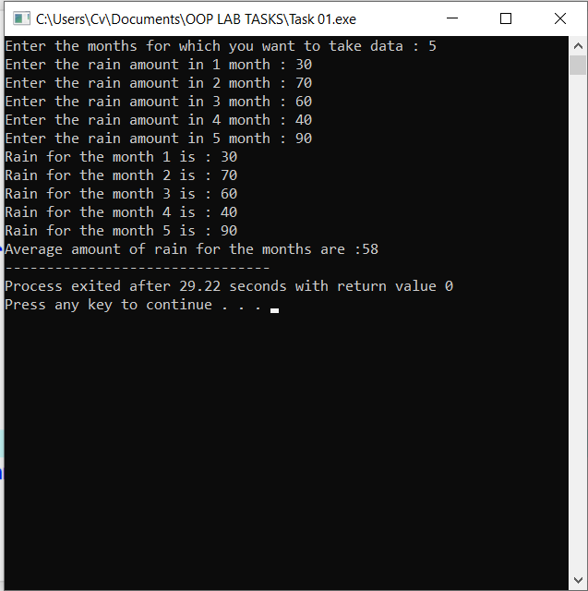

**Task # 02:**

Implement a C++ program to find a minimum and maximum from a user defined 2D array. Implement functions with the name of **Min** and **Max** to find the desired output.

Note: Take the size of the array from the user.

**Code:**

**#include <iostream>**

**using namespace std;**

**int Min(int** arr, int row, int column);**

**int Max(int** arr, int row, int column);**

**int main()**

**{**

**int row, column;**

**cout<<"Enter the row size of array : ";**

**cin>>row;**

**cout<<"Enter the column size of array : ";**

**cin>>column;**

**int** arr;**

**arr = new int*[row];**

**for (int i=0; i<row; i++)**

**arr[i] = new int[column];**

**for(int a=0; a<row; a++)**

**{**

**for(int b=0; b<column; b++)**

**{**

**cout<<"Enter any number in arr["<<a<<"]["<<b<<"] : ";**

**cin>>arr[a][b];**

**}**

**}**

**for(int a=0; a<row; a++)**

**{**

**for(int b=0; b<column; b++)**

**{**

**cout<<"Number in arr["<<a<<"]["<<b<<"] is : "<<arr[a][b]<<endl;**

**}**

**}**

**cout<<"Minimum value in array is : "<< Min(arr, row, column)<<endl;**

**cout<<"Maximum value in array is : "<< Max(arr, row, column)<<endl;**

**return 0;**

**}**

**int Min(int** arr, int row, int column)**

**{**

**int min=arr[0][0];**

**for (int i = 0; i<row; i++)**

**{**

**for (int j = 0; j <column; j++)**

**{**

**if (arr[i][j] < min)**

**{**

**min = arr[i][j];**

**}**

**}**

**}**

**return min;**

**}**

**int Max(int** arr, int row, int column)**

**{**

**int max=arr[0][0];**

**for (int i = 0; i <row; i++)**

**{**

**for (int j = 0; j <column; j++)**

**{**

**if (arr[i][j]>max)**

**{**

**max = arr[i][j];**

**}**

**}**

**}**

**return max;**

**}**

**Output:**

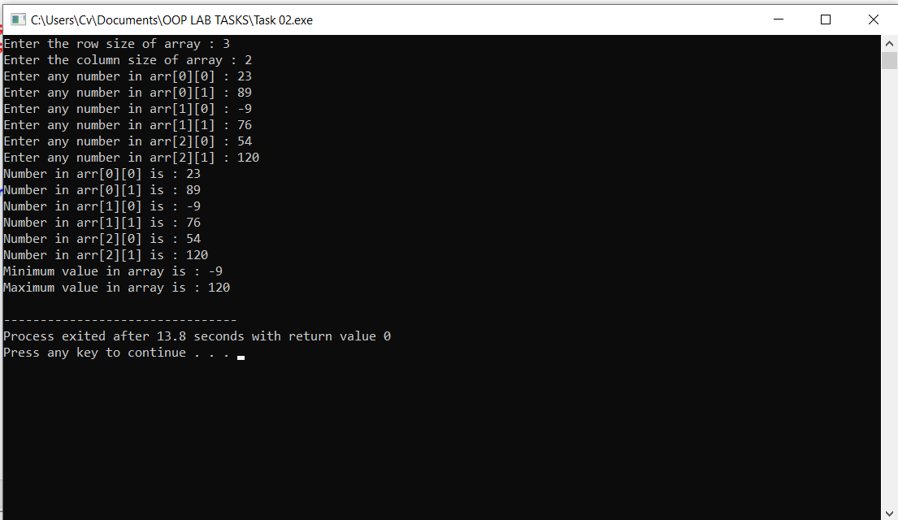

**Results & Observations:**

In this Lab I’ve learned about the concept of 1-D & 2-D arrays and also understand that how array can be passed to a function as argument & returned by a function. In 2-D arrays we use two parentheses (one for row and other for column) to define the size of array, while using in the function we must enter the size in any row/column otherwise it’ll give an error.